AP Psychology Name_________________________
Unit 8

Maslow’s Hierarchy of Needs

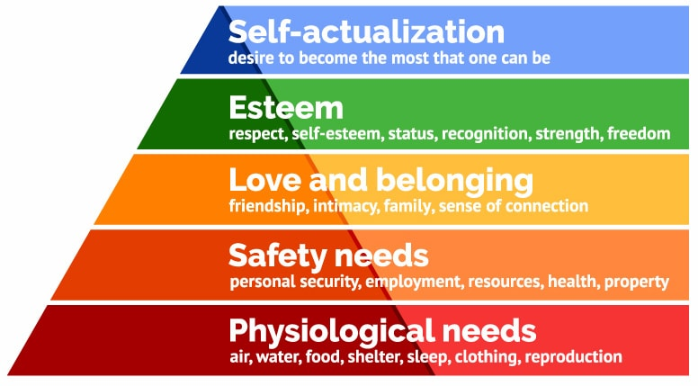

Directions: Identify the level (1-5, with 1 being Physiological Needs) by applying Maslow’s theory to the following real life scenarios.

- As Tryone studied in smaller chunks of time, repeatedly over a few weeks, his quiz grades improved. He began to see himself as a good student as did his teachers.

- Lastri, 7 years old, becomes a Siaga Mula in the Geraken Pramuka (Indonesian Girl Scouts), proudly wears her new badge and red scarf to the meeting.

- Former Vice-President Al Gore’s film, An Inconvenient Truth, is nominated for an Oscar and wins. Then, Al Gore wins the 2007 Nobel Peace Prize!

- As the conflict between the Sri Lankan government and Liberation Tigers of Tamil Eelam (L.T.T.E.) escalated, women and children ran through the river to escape being shelled from both sides.

- Liam’s stomach was grumbling during class. He watched the hands on the clock tick toward the end of class and lunch time, not really hearing Mr. McNeely’s lecture.

- The perpetrators at Columbine H.S. felt isolated and alienated from their peers, lashing out in a hate-filled rampage.

- In an effort to make a productive change for the better, a smiling Oprah Winfrey spent $40 million dollars opening a new school for girls in South Africa.

- On Valentine’s Day, everyone in Mrs. French’s 3rd grade class exchanged valentines with a personalized message about why each student is “a nice person”.

- Larry, age 12, was afraid to go to school because another boy was constantly calling him names, embarrassing him, so he pretended to be sick and stayed home.

- Daquain was the only one from his high school class who went to UCLA. He and his roommate happily pledged and joined a fraternity.

- Teri learned basic kung fu in an effort to feel better about working the night shift at CVS.

- After the restructuring of the company in an effort to reduce costs, Azhure was happy to accept her appointment as supervisor of two departments.

- While learning how to scuba dive, Ernesto’s air tank malfunctioned, causing the instructors to take emergency action.

- A few months after her marriage, Vanessa began to fully enjoy her new role as wife and partner to her husband.

- While serving a 10-year prison term form armed robbery, Charlie vowed to change his life, completed an online G.E.D. and then earned his B.S. degree in marketing.

- In 2009, as an unemployment rate climbed to 10.1% in Cairo, Sebek despaired of ever being able to care properly for his family, as a man should.

